Regional Trauma Advisory Committee
September 2022 Meeting Agenda
Tuesday, 20st September 2022 @ 1:00 pm
- Call to Order and Welcome

- Introductions: Attendees are listed below

Crystal Shelnutt | Dr. Kurt Horst | Heather Morgan | Ryan Hollingsworth
Ronnie Almond | Glenn henry | Jack Mundy | Karen Horst
Brandi Harris | April Dorsett | Aaron Ross | Anna Sheridan
Tim Bohannon | Dawn Armeni | Chris Threlkeld | Don Cargile
Beth Seymore | Kim Reusmann | Christina Mathis | Gina Soloman
Bobby Smith | Jason Lewis | Kourtney Shelton | Kevin Locke
Chuck Almond

- Updates
- Stop the Bleed: Crystal Shelnutt provides an update
  - STB: GTC approval and new projects
    - At the August GTC meeting in St. Simons the RTAC coordinators presented a request for expansion of the STB program. With 98% of public school and 80% of busses completed the program has been a tremendous success since its inception in 2017. The commission approved expansion of the STB project to include public education institutions, Law enforcement*, and government agencies. See proposal below. Schools and busses will remain a top priority for completion but many barriers have delayed that in some regions.
*Law Enforcement is approved pending additional guidance from the governor’s office. RX RTAC will provide additional information about application periods and a distribution plan as it becomes available. Region 10 has 100% completion of the school STB program and only 1 remaining bus garage. Discussion around completion of the Jefferson City School bus garage included a potential connection with the new school superintendent. Dr. Horst will reach out for assistance.

    - Success of the Region 10 STB pilot projects with government agencies was discussed.
      - Madison County has trained more than 50 county employees and has deployed all kits allocated.
      - Oglethorpe County continues to train county employees and fire departments and allocate kits as training is completed.
      - ACCFD has distributed the STB virtual training to all county employees and will be completing in person skills at the upcoming Employee Health Fair.

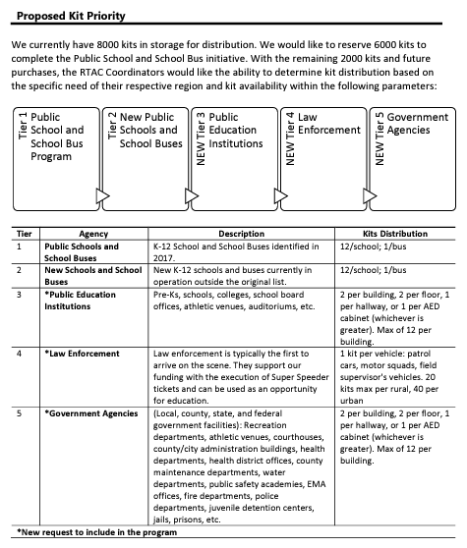
  - Online Training: https://www.stopthebleed.org/training/online-course/
    - All are encouraged to share the online training course with their services and contacts! Crystal is available to assist with skills sessions and coordination of equipment.
  - Available equipment: the region has 5 new wound packers and dozens of the ‘pool noodle’ trainers with blue STB training kits. Email Crystal to reserve.

- Home Depot Purchases- 3 of the reciprocating saws have been delivered, we are awaiting the additional 7 units and rolling kits. GTC has reached out to Home Depot with no resolution to the delay.
- Skills Lab- Kevin with Barrow County Fire states he has a possible location and will coordinate a date with GEMSA for the 2023 Region 10 Trauma Skills Lab
- Blood Products Pilot Project Update: Heather Morgan provides an update from Piedmont. The IT department from Piedmont Atlanta has scheduled a meeting with Thermo Scientific to resolve the security conflicts between the two systems. Ryan Hollingsworth volunteers to assist in developing a data system that will allow the hospital to access real-time temperature monitoring. Heather confirms that all equipment is ready to be used in the blood bank and the only remaining component is the validation of the thermostat.

- New Business
- Safe Kids- April Dorsett presented on the worldwide organization Safe Kids that has Georgia headquarters located at CHOA. April works for Piedmont Athens and discussed her outreach and injury prevention programs. In addition to community events, April also distributes car seats to anyone who may be in need. She provided her contact information and advised EMS agencies to reach out as needed following wrecks in which a car seat needs replacement or anytime a need is identified. Ryan Hollingsworth included that he is a car set technician and an available resource for the region.
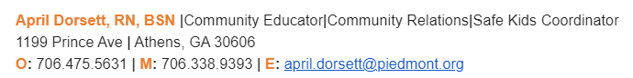
- Dr. Horst lead a discussion on TXA use in the region. Topics included what services have it available for use and any variations on dosing or indications for use. Most services represented in the region have TXA on all ALS units but many were unaware of the recent changes to CoTCCC recommendations on dosing and administration procedures.
- Updates on Georgia Trauma Centers: Dr. Horst lead a discussion on the recently announced closure of Atlanta Medical Center. He provided a handout discussing the primary differences of Level 1 vs Level 2 trauma centers and the capabilities of each.
- Region 2 Trauma Conference- a flier was made available for the October conference and all are encouraged to attend in person or virtually!
- Community Events and Engagement- The region 10 RTAC hopes to have a website available soon. Please send all relevant events and announcements to Crystal and let her know if you need any assistance.

- Questions
- Adjournment
