o
RTAC 7 Subcommittee Meeting
ZOOM
January 31, 2023

Subcommittee Members Absent
Subcommittee Members Present

Duane Montgomery Chairman Dr. Scott Hannay – Medical Oversight
Mary Bizilia – Vice Chairman, Education
Brian Dorriety – Secretary, RTAC 7 Coordinator
Kelly Gasser – Performance Improvement
Shalonda Wright – Trauma Registrar
Marylin Dunlap- Trauma Registrar
Pam Fair – Injury Prevention

Representing
Guests

Liz Atkins Georgia Trauma Commission
Jules Hazen CFEMS (Muscogee County)
Darrell Enfinger DPH
Ricky Bias AIR EVAC
Tom Faulkner Harris County EMS
Greg Stewart Stewart County EMS
Frank Killebrew State Office of EMS and Trauma
David Bucher Chattahoochee County
Dr. Tim Boone AVLS
Kristi Burnette Community Ambulance Service
George Joiner Macon County EMS
Quincy Searcy Harris County EMS
Scott Campbell Webster County EMS
Jack Rodgers Piedmont Columbus Regional
Chamaine Bjornson Piedmont Columbus Regional, Peds Dept
Jimmy Carver Talbot County EMS
Paula Carter Columbus Technical College, Paramedic Program Director
Jimmy Carver Talbot County EMS
Alycia Blanton Piedmont Columbus Regional Northside
Jenny Weatherby State Office of EMS and Trauma

Introduction
Chairman Duane Montgomery welcoming remarks.

Call to Order by Duane Montgomery
Duane called the January 31, 2023 meeting of the RTAC 7 Subcommittee to order at 2:00 P.M.
Roll Call recorded by Brian Dorriety
Old minutes were motioned to be approved by Mary Bizilia. A second on the motion was made by Jack Rodgers Motion was approved.

Old Business
Stop the Bleed- Brian Dorriety

- Brian conducted STB Instructor Training with the Taylor County School District School Board Lead Nurse and 12 other Nurses.
- Trained 6 new STB instructors at Air EVAC 77.
- Brian stated that Region 7 has 5 STB Hemorrhage control Training kits available for use. Welcome to check them out for use at any time.
- Future training in other counties to follow soon.

Home Depot Funds- Sanitation Equipment

- All of the Home Depot Equipment Grant Funds equipment were delivered.
- Brian thanked Katie Hamilton for all of her help and support for making sure all of the equipment was ordered and received.

Brian advised the committee that the RTAC Trauma Plan was updated on January 17, 2023 and sent into the Georgia Trauma Commission for approval.

Changes on pages 5,22,34,35,36

Hospital / Trauma Facility Report- Jack Rodgers, ED Director at PCR

- Jack stated that Piedmont Columbus Regional would be recertifying ACS in May and they will be visiting via virtual this time.
.
- TNCC course are being requested.

Hospital- Alycia Blanton, Northside ED Director

- EMS has been doing a great job at screening the trauma patients and getting them to the appropriate facility. We are still having a lot of walk in trauma patients

Education-Mary Bizilia, RN, Trauma Program Coordinator

- Region 7 is hosted our 4thannual Trauma Skills Lab in January 20, 2023. We had 165 register and 152 show up in attendance.
- We are starting off the new year and look forwarded to offering as much training and education opportunities as possible for our region. Please reach out to of us if you have any special request for future training in trauma
- Our goal is to make Region 7 the best region in Trauma Care and Injury Prevention. We need your help and support in order to be successful.

Kelly Gasser, RN, PI
2nd Quarter Data
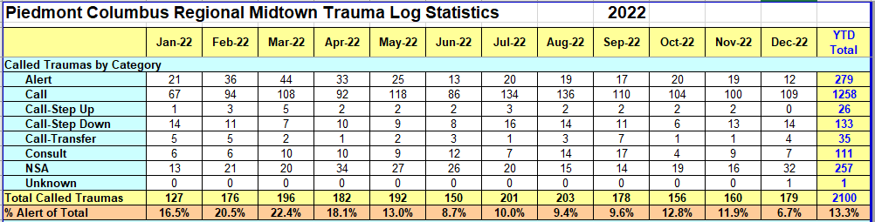
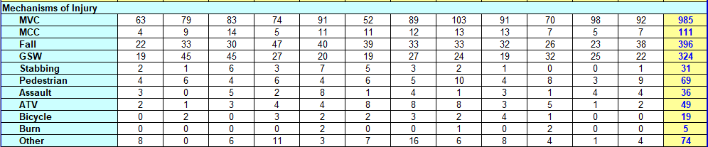

RTAC Pilot – Trip Reports

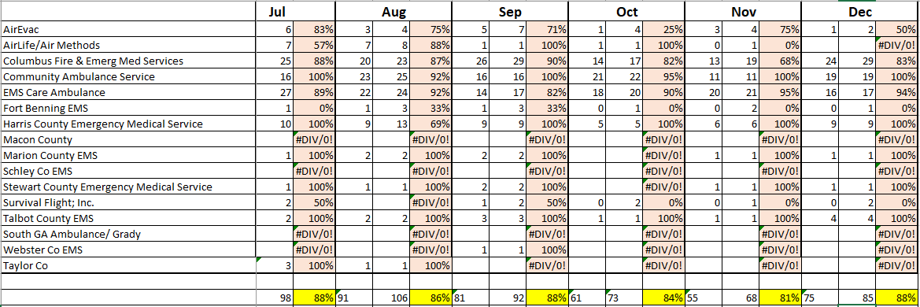

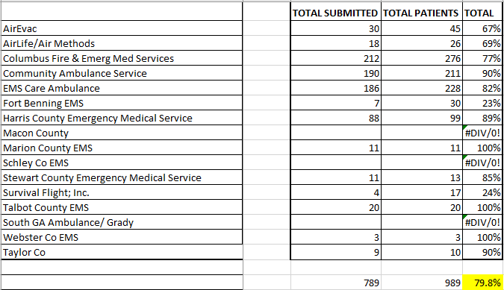

Injury Prevention – Pam Fair

Strategic Plans for 2023 in the works!

ADULT INJURY PREVENTION
Fall Prevention:
- Muscogee - Matter of Balance & Tai Chi Classes for 2023 in partnership with Area Agency on Aging.
- $25 for each entire class. Area Agency on Aging may be open to a class in your county! Inquire with them.

Motor Vehicle: Teen Driving Summit
The Piedmont Columbus Regional, RTAC7 participated in a Distracted Driving Summit that the injury prevention program and WellStar brought to Columbus State University. They partnered with the Lutzie43 Foundation and held these summits for high school from region 7.
We had over 700 students attend on January 31, 2023.

Penetrating Injuries:
The cure violence Coordinator has been hired! His name is Jerome Lawson.
He plans to join our ATIP Committee and we look forward to the work ahead.

Safe Kids Columbus
- Booster Seat Education/Distribution Events: Elem Schools in
Muscogee + Russell County AL in March 2023. Plans to share this
model in West Central Health District – rural counties.
- River Savvy Kids Event – Free Life Jackets for Kids event coming in
May 2023; stay tuned for more details.
- Safe Sleep Classes – 2023 extended to rural counties in Hospital
Region/West Central Health District.
- Low-Cost Car Seat Classes – Muscogee County, $20 per car seat

Medical Over Sight – Dr. Scott Hannay, Trauma Medical Director

Nothing to report

Air Medical Services- Ricky Bias, AIR EVAC
Nothing to report

OEMS&T – Frank Killebrew, Jenny Weatherby, State Office of EMS & Trauma
- Macon County EMS will be holding an ITLS Class in February.

Pediatrics – Charmaine Bjornson, RN, Pediatrics Emergency Department Manager

- Lindsay Martinez is the new education Coordinator for the PEDS ED.
- PCR will be receiving a new PEDS Surgeon in the next couple of months
- PCR is trying to hire paramedics to work in the PED ED
- PCR PEDS ED only has 1 car seat instructor and would like more certified instructors

Emergency Preparedness – Darrell Enfinger, Terry Parish, Daryl Feagins

Nothing to report

Duane Montgomery opened the floor for any new business.
- Duane stated that Schley County will be hosting a child safety seat technician class along with CPR, First Aid and Stop the bleed classes in the upcoming months.

AVLS- Dr. Tim Boone
Stated that Region 7 has 20 active and 9 non- active – 69% active. Muscogee county is the only county not using the AVLS. They are using their own system.

GTC- Liz Atkins, Executive Director
- The ACS Rural Focused Georgia Consult recording is on the GTC website
- Final report should be ready by the end of Marchand sent out to all regions

Next RTAC Meeting tentative for April 25, 2023

Meeting Adjourned!

